**Question 1**

1(a)

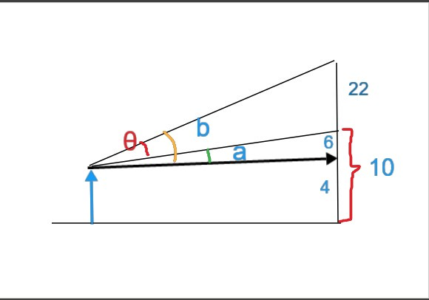

As shown in the picture, $θ$ = b-a

∵ a= $\tan^{-1}{\frac{6}{x}}$

b= $\tan^{-1}{\frac{28}{x}}$

∴ $θ=\tan^{-1}{\frac{28}{x}}$- $\tan^{-1}{\frac{6}{x}}$ (proven)

1(b)

from 1(a), $θ=\tan^{-1}{\frac{28}{x}}$- $\tan^{-1}{\frac{6}{x}}$

∴ tan $θ=tan⁡(\tan^{-1}{\frac{28}{x}}$- $\tan^{-1}{\frac{6}{x}}$)

= $\frac{tan{(tan}^{-1}{\frac{28}{x}} )-tan(\tan^{-1}{\frac{6}{x}})}{1+tan{(tan}^{-1}{\frac{28}{x}} )tan(\tan^{-1}{\frac{6}{x}})}$

= $\frac{22x}{x^{2}+168}$

$θ$, a and b are all within the first and second quadrant

${∵tan}^{-1}{\frac{6}{x}} and \tan^{-1}{\frac{28}{x}}$ are positive because x>0

∴a>0,b>0

∴ $θ$, a and b are all in the first quadrant

∵b>a

∴ b-a is also in the first quadrant, $\tan^{-1} tanθ$ = $θ$ is true

∵ $θ$ >0

∴ $\frac{22x}{x^{2}+168}$ >0 (x is positive)

∴ $θ=\tan^{-1}{\frac{22x}{x^{2}+168}}$ (Proven)

1(c)

By using calculator, substitute 7, 10,13,16,19 respectively into the equation

$$θ=\tan^{-1}{\frac{22x}{x^{2}+168}}$$

The values of $θ$, rounded to 4 decimal places, are 35.3625 **°,39.3824 °, 40.3201 °, 39.6991 °, 38.3147 ° respectively.**

**We noticed that the value of $θ$** reaches maximum when the value of $x$ is 13.After that, the value of $θ$ decreases while $x$ increases.

**Using Python and Geogebra as an approach to solve Question 1(c)**

Using the programming language Python, we can plot a graph to find out the maximum value of $θ$.

The code: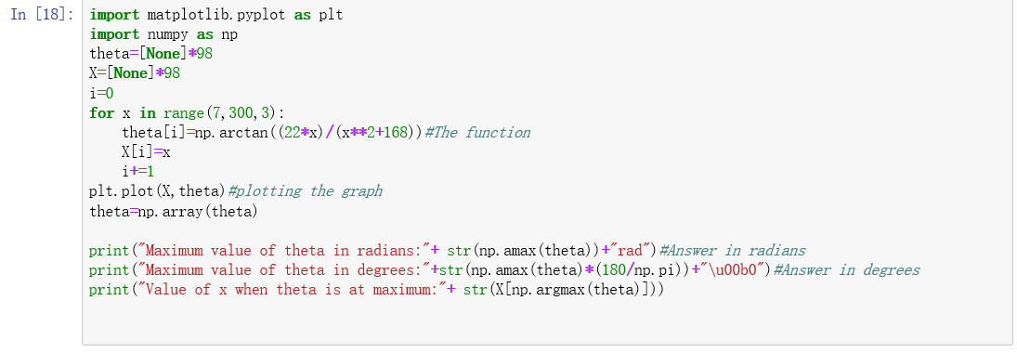

Output:

Also, we plotted a graph with Geogebra, a simple-to-use online math tool to find the maximum value of theta. The value of x (rounded from 12.9614815310224) is 13. Therefore, the person should sit on the third row to get the maximum view.

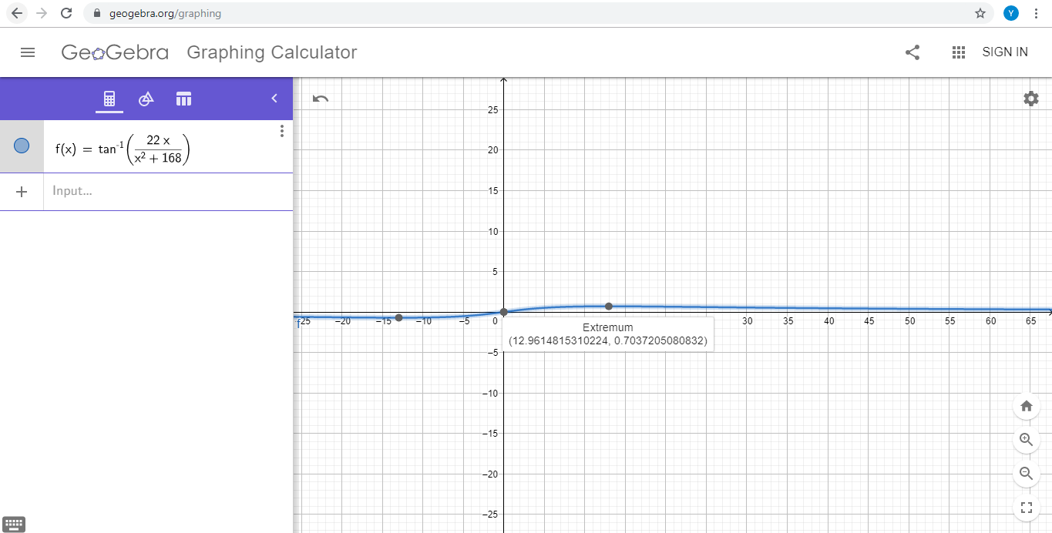

**Question 2**

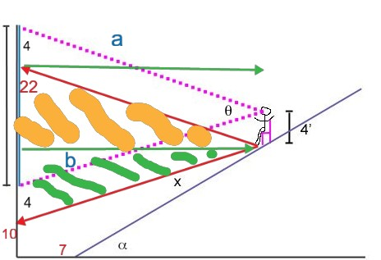

$∝$ =25°

2(a)

As shown in the picture above, 2 red lines parallel to a and b are drawn. The green lines are parallel to the horizontal.

The red line parallel to a has the same length with a because it forms a parallelogram with the screen, the person, a and itself.

$\frac{Horizontal distance of the person from the bottom of the incline}{x}$ =cos $∝$

Horizontal distance of the person from the bottom of the incline =xcos $∝$

$\frac{ Vertical distance of the person from the bottom of the incline}{x}$ =sin $∝$

Vertical distance of the person from the bottom of the incline =xsin $∝$

Therefore, in the right-angled triangle shaded with yellow,

$a^{2}{=(7+xcos a)}^{2}$ [The length of the green line squared) ${]+(28-xsin a )}^{2}$ [The length of the screen in the right-angled triangle squared]

(Pythagorean Theorem)

For the same reason, in the right-angled triangle shaded with green,

$b^{2}$ = ${(7+xcos a)}^{2}$ [The length of the green line squared] ${+(xsin a-6)}^{2}$ [The length of the screen in the right-angled triangle squared]

Applying cosine rule, $cosθ$ = $\frac{ a^{2}+b^{2}-{22}^{2}}{2ab}$

∴ $θ$ = $\cos^{-1}{\frac{ a^{2}+b^{2}-484}{2ab}}$

($0°<θ<180°,therefore \cos^{-1}{cosθ=θ is true}$)

2(b)

By using calculator, substitute 0, 3, 6, 9, 12 respectively into the equation

$θ=\cos^{-1}{\frac{ a^{2}+b^{2}-484}{2ab}}$**,** where

$a^{2}{=(7+xcos a)}^{2}{+(28-xsin a )}^{2}$

$b^{2}$ = ${(7+xcos a)}^{2}$ ${+(xsin a-6)}^{2}$

The values of $θ$, rounded to 4 decimal places, are 35.3625 **°**, 44.0590 **°**, 48.4031 **°**, 49.6912 **°**, 49.0855 **°. We noticed that the value of $θ$** reaches maximum when the value of $x$ is 9.After that, the value of $θ$ decreases while $x$ increases.

To understand more about the relationship of x with $θ,$ we plot the graph of $θ$ against x in Python.

The code: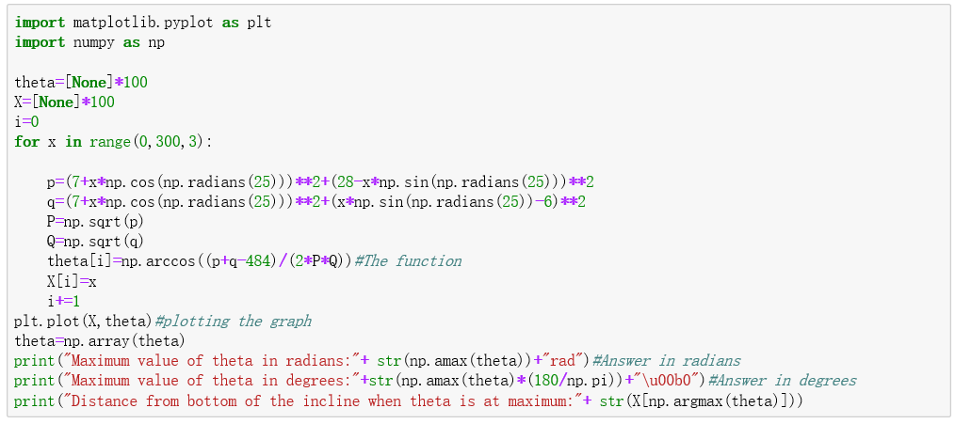

Output: 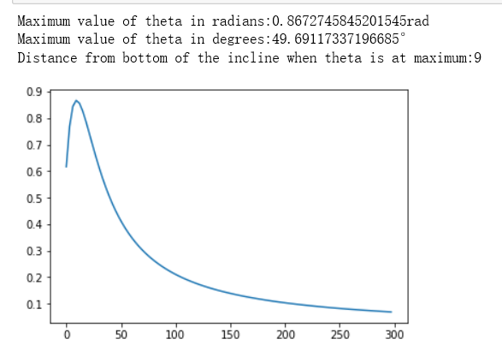

As shown in the graph, the person should sit in the fourth row (9 ft away from the bottom of the incline) in order to get the maximum view.

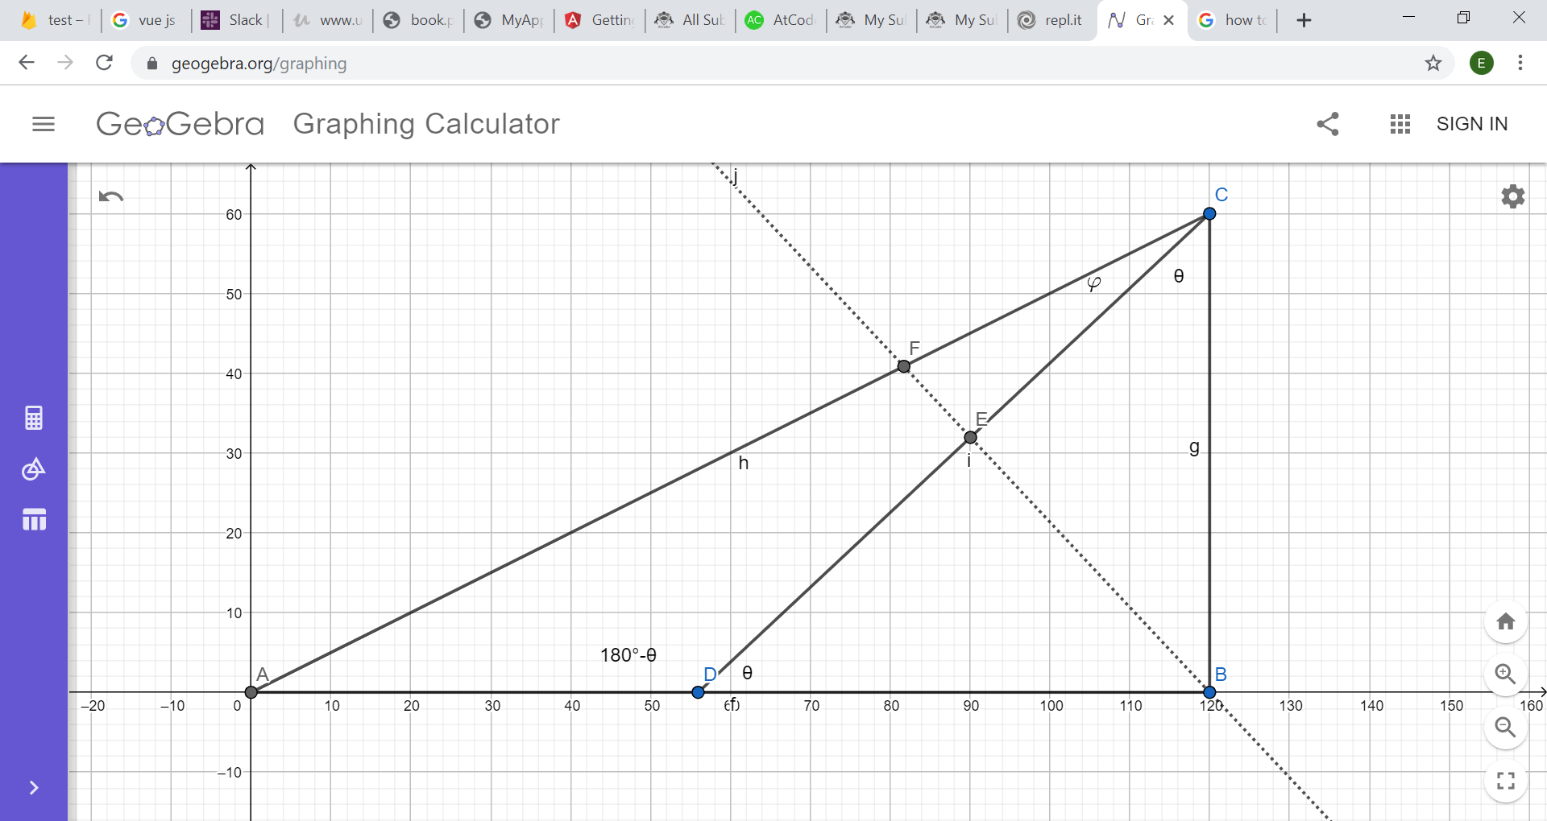

**Question()**

Prove: tanθ =3tan $φ$

Method 1:

In triangle CDB, $\frac{1}{\sin{θ}}$ = $\frac{DC}{\sin{2θ }}$

DC=2cos θ

Construct a line BF perpendicular to line CD, thus CE=cos θ= $\frac{DC}{2}$,

By Menelaus Theorem, $\frac{AF}{FC}$ x $\frac{CE}{ED}$ x $\frac{DB}{BA}$ = 1

$\frac{AF}{ FC}=\frac{2}{1}$

In triangle CEF,

By sine rule, $\frac{CE}{\sin{(90°-φ)}}$ = $\frac{\frac{AB}{3}}{\sin{90° }}$

$\frac{cosθ}{cosφ}$ = $\frac{AB}{3}$ (1)

In triangle CAD,

By sine rule, $\frac{AC}{\sin{θ}}$ = $\frac{1}{\sin{φ }}$

$\frac{sinθ}{sinφ}$ = AC (2)

$\frac{(1)}{(2)}$, tanθ =3tan $φ$. (Proved)

Method 2:

In triangle ABC,

$\frac{2}{sin⁡(θ+φ)}$ = $\frac{1}{sin⁡(θ-φ)}$

tanθ =3tan $φ$. (Proved)

**Question 11**

If tan A= $\frac{q\sin{B}}{p+q\cos{B}}$, prove that tan (B-A) = $\frac{p\sin{B}}{q+p\cos{B}}$.

Solution:

L.H.S. = tan (B-A)

= $\frac{\tan{B-\tan{A}}}{1+\tan{B\tan{A}}}$

= $\frac{\frac{ptan B+qsin B-qsin B}{p+qcos B}}{\frac{p+qcos B+qsin Btan B}{p+qcos B}}$

= $\frac{ptan B}{p+qcos B+qsin Btan B}$

= $\frac{ptan Bcos B}{pcos B+q\cos^{2}B+q\sin^{2}B}$

= $\frac{psin B}{pcos B+q(\sin^{2}B+\cos^{2}B)}$

= $\frac{psin B}{pcos B+q}$

= R.H.S. (proven)